UML Object Diagram

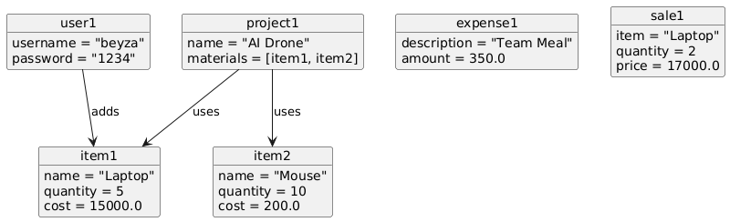

@startuml

object user1 {

username = "beyza"

password = "1234"

}

object item1 {

name = "Laptop"

quantity = 5

cost = 15000.0

}

object item2 {

name = "Mouse"

quantity = 10

cost = 200.0

}

object project1 {

name = "AI Drone"

materials = [item1, item2]

}

object expense1 {

description = "Team Meal"

amount = 350.0

}

object sale1 {

item = "Laptop"

quantity = 2

price = 17000.0

}

user1 --> item1 : adds

project1 --> item1 : uses

project1 --> item2 : uses

@enduml